

Faculty of Electronics, Telecommunications and Information Technology

Computer Aided Design

Sinewave and triangle wave generator

Supervisors: Student:
Raul Fizeșan Candrea Sandra
ETTI, Group:2023

Introduction:
A signal generator, a general-purpose piece of test equipment, performs numerous measurements for a variety of applications requiring electromagnetic wave signals as stimuli. Its roots trace back to the beginnings of the electronic test-and-measurement industry. The first product, developed by Hewlett-Packard Company (now known as Agilent Technologies), was the model 200A audio oscillator. One of HP’s first customers was the Walt Disney Company—in 1940, Walt Disney purchased eight audio oscillators to calibrate the breakthrough sound system it developed for the movie “Fantasia.”
Today, RF signal generators are widely used throughout the electronics industry, including aerospace/defense electronics and wireless communications. Typical applications include RF/IF signal generation and LO substitution, as well as radar, GPS, and avionics signal simulation.In modern wireless communications systems, signal generators supporting a range of digital-modulation formats are commonly used to test digital receivers and transmitters against increasingly complex requirements.
Regardless of the industry or application, getting the most value out of the signal generator requires a good understanding of its basic operation and function, as well as its key specifications. Another critical factor is becoming familiar with a signal generator’s ability to go beyond general-purpose applications to simulating advanced signals with impairments, interference, and waveform correction.

- Requirements:
We will simulate in OrCAD an example of circuit to generate a sinusoidal and a triangle signal with the following parameters:
- Sinewave: 6 V;
- Triangle wave: 9 V
- Frequency: 20kHz-40kHz

- Schematic:

The first component of the circuit represents a Wien Bridge Oscillator, for the sinusoidal wave. The signal generated previously enters three stages of amplification, built with three operational amplifiers. Between the second and the third operational amplifier is a RC filter which removes the off-set of the sinewave.
Then, the obtained signal enters a differentiator which transforms into a triangle wave with the help of a resistor and a capacitor.
The last part of the circuit represents another amplifier stage which raises the amplitude of the triangle wave to the desired value.

Components used:
- 6 operational amplifiers (LT1221);
- 12 resistors;
- 5 capacitors;
- 12 DC sources;

Calculation:
For f=30 kHz:
- Wein Bridge:
We suppose that R₁=R₂=3kΩ =>
f= $\frac{1}{2πRC}$ => C=$\frac{1}{2πfR}$=$\frac{1}{6,28*30*3*{10}^{6}}$=1,77nF
R4=2*R3
- First amplifier:
A₁=1+R₉/R₈=1+1,5*10⁶/10³=1501 (1)
U6=> vout₁=1.5mV (2)
- & (2) => vout₂=vout₁*A₁=1.5*10⁻³*1501=2.2V

- Second amplifier:
A₂=1+R₁₀/R₁₁=1+2.32*10³/10³=1+2,3=3.3
vout₃=vout₂*A₂=3.3*2.2 ~= 7V

- Third amplifier:
Vout₅=1.125V
A₃=1+R₁₉/R₂₁
Vout₆=vout₅*A₅

Types of simulations:
- Transient Regime:

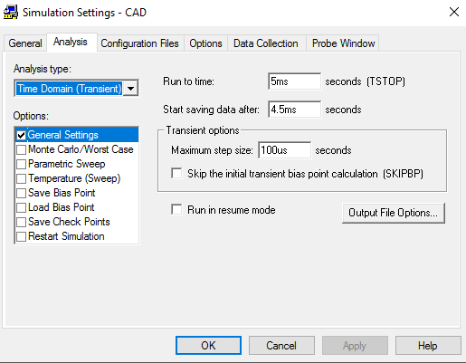

- Parametric simulation:
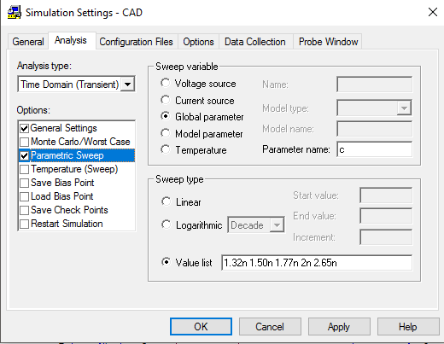

- Monte Carlo simulation:
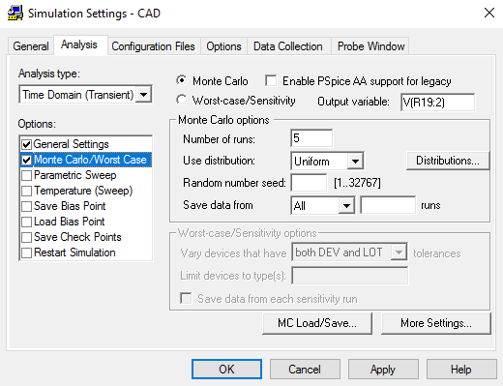

- Worst case:
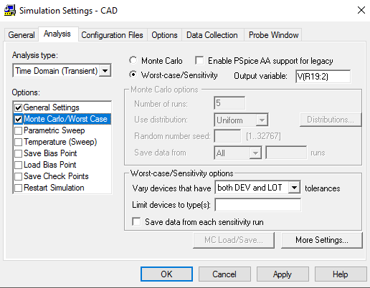

This schematic is ideal, but if we use real components, the result is:

Resistors and capacitors for the real variant
Resistors:
http://elcodis.com/parts/4284322/BWF237-05T-1K.html#datasheet
http://elcodis.com/parts/1689226/NHR_2-T220_51000_OHM_5.html#datasheet
http://elcodis.com/parts/3385568/16370100402.html#datasheet
http://elcodis.com/parts/1636508/CFR-25JR-910R.html#datasheet
http://elcodis.com/parts/1579615/S-4_4700_OHM_5.html#datasheet
Capacitors:
http://elcodis.com/parts/1975573/564R30GAD18.html#datasheet
http://elcodis.com/parts/2979204/FSCEX_820PF_1250V.html#datasheet
http://elcodis.com/parts/2979520/PCHVSWF_220NF_1KV.html#datasheet

Bibliography
[1] |  | P. Professor Gabriel Oltean, "Fundamental Electronic Circuits," [Online]. Available: http://bel.utcluj.ro/dce/didactic/fec/fec.htm.
[2] |  | R. Fizeșan, G. Chindriș and O. Pop, Computer Aided Design - Laboratory Applications, Cluj-Napoca: U.T. Press, 2015.

